HANON TEST – INSTRUCTIONS

# Jazz Plugin Installation and activation - MIDI input

The HANON TEST application requires the installation of **Jazz plugin.** It can be downloaded from this site:

<http://jazz-soft.net/download/Jazz-Plugin/>

After downloading the installation program, click on it for its execution. Keep pressing <OK> and <Next> until done.

 When the Hanon Test application is executed thel browser will request the authorization to activate the plugin. Confirm that you always allow the execution of Jazz plugin for this application and reload the page clicking on the reload button or pressing F5.

Google chrome indicates the blocked plugin with an icon signed with a red cross in the address bar (see figure).Click on the red cross and activate the plugin. Then reload the page using F5

At this point you should have a MIDI keyboard connected to your PC.If it is not already selected, select the MIDI input you intend to use from the dropdown menu included in the **OPTIONS** panel.

# Metronome setup

The speed of the metronome, in Bpm (beats per minute) can be selected in various ways:

* Dragging the cursor up and down with the mouse, as on a real metronome.
* By clicking on the buttons **+1, +5, -1, -5** that increase or decrease the speed of the metronome of the corresponding amount.
* Pressing the second black key on the MIDI keyboard to decrease of 5, or the third black key to increment of 5.
* Using the option "**auto bpm +5**" outlined below.

# Opzioni

In the **Options** panel, you can enable or disable the following options:

* **Insert Base** - Adds a musical background to the exercise
* **Insert melody** - allows you to hear the notes of the exercise
* **Loop** - Enable the automatic repetition of the exercise
* **Auto + 5 bpm** - If selected automatically increases the Bpm of 5 if the exercise has been completed with a score greater than 70.
* **Auto seq**. - At the end of an exercise automatically selects the next.

In the grid below, you can select the number (1 to 20) for the Hanon exercise that you intend to execute.

Pressing the second-to-last black key MIDI keyboard this number is decreased, while by pressing the last black key the number is increased.

# Test execution

The test is activated by pressing the START button located under the metronome. Alternatively you can start the test by pressing the first black button of the MIDI keyboard. In the same way the test can be stopped..

During the test, the two lower bars labeled "RIGHT" and "LEFT" give an indication of the precision with which the right and left hands performed the current note. The perfect execution, that is, with the note that starts and ends exactly at the beginning and end of the corresponding time interval sees bars positioned as in the figure above. Any delays or advances in the beginning of the note will see the left edge of the bar to move forward or backward respectively. Similarly the right edge of the bar will move forward or backward depending on the errors on the end of the note.

As an indication, the width of the brown square corresponds to ¼ of the theoretical note length.

In addition to moving, the two bars also change color. A note left hand played perfectly is dark green, and the right hand is dark blue. The color lightens with the increase the error, until they become white for a very big error. If the note is completely wrong or off the bar turns red.

The performance of these two bars over time is shown on two vertical graphs, represented here on the right.

The position of the two light brown bands corresponds to the position of the two squares on the sides of the horizontal bars mentioned above, therefore the correct range of execution is the one between them.

Even in these graphs, the color is much more clear how much worse is the performance. Red if totally wrong or absent.

At the top of the screen is displayed a double stave with notes for the exercise. These notes will gradually be colored with the same criterion.

The two graphs immediately to the sides of the central table represent the speed of played notes, corresponding to the pressure exerted on the keys of the MIDI keyboard. Useful to give an idea of how this pressure is constant.

# The central table

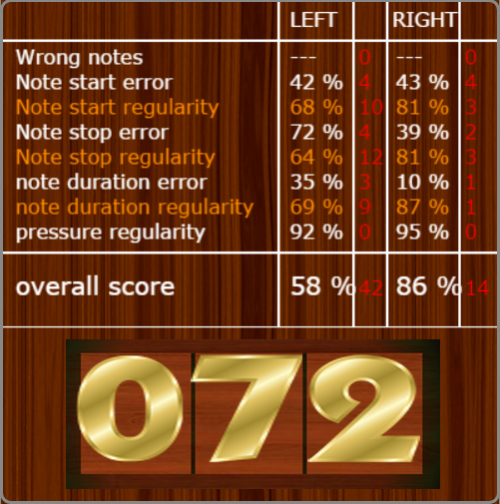The central table provides statistical information on the test. For each hand provides the following information:

* **Wrong notes** - how many wrong notes were played
* **notes start error** - the average value of the error on the start of the note, as a percentage of the length of the note
* **note start regularity** - The indication of how much the start of the note is constant
* **notes stop error** - the average value of the error on the end of the note, as a percentage of the length of the note
* **note stop regularity** - The indication of how much the end of the note is constant
* **Notes duration error** - the average value of the error on the length of the note, as a percentage of the length of the note
* **note stop regularity** - The indication of how much the duration of the note is constant
* **Pressure regularity** - constancy in the value of key presses, a percentage of the mean value (0 = perfectly constant, 100 = maximum instability).
* **Overall score** - a score calculated on the combination of the above values. The theoretical maximum value is 100, unattainable in practice. A good value is 80.

The red numbers indicate how many points of the total score were lost for each individual item.

The number reported in great overall score is the average of the two hands. If this value at the end of the exercise exceeds 70 and **auto bpm + 5** is enabled the Bpm value will be automatically increased by 5.

# In detail

Pressing the **DETAILS** button you access a detailed display of the just completed exercise. You can drag the graphs to the right and left with the mouse. Pressing the **NOTE ON** button you can listen to the notes of the exercise while dragging the graph. You can also perform an exercise keeping this view. Press the **EXIT** button to return to the main screen

# Tip

I found very convenient the free **Splashtop** application which lets you duplicate the PC screen on a tablet. In this way it is possible to perform the exercises in real time by consulting the result on the tablet placed on the lectern of the keyboard. For information http://www.splashtop.com/.

.